

THE JUDICIARY

EPAYMENT TEST LINKS and PLAN

## 1. Introductions

For the purpose of this test, we have set up a testing server in the following link.

***<http://staging.court.go.ke/epay/index.php/api/validate>***

In addition to this, we have setup a production server complete with SSL Certificate and would also be setting up VPN on the same server. The production server will e hosted in the following link

***[http://efiling.court.go.ke/epay/index.php/api/validate](http://staging.court.go.ke/epay/index.php/api/validate)***.

**The KCB payment assume the following steps.**

1. The customer approach the KCB payment channel with customer payment reference. The customer can choose to use the following channels.

* MPESA
* BRANCH
* VISA
* Online Banking
* Cash Transfer
* EFT and RTGS

1. Once KCB receive payment request, the KCB switch verifies the customer reference from the efiling portal.
2. Once the request is received in the efiling portal, we send a verification code which confirms the code with amount to be paid of mark as invalid.
3. Once a confirmation is received at the KCB endpoint confirming the customer reference and amount, KCB go ahead to credit the customer the exact amount.
4. After processing payment, KCB sends payment information to the efiling portal
5. The efiling portal responds back with the Case number and status.

## Below is the Test scenario

Using postman tool I have presented the following validation options. Attached also depicts some of the screenshots for your reference. Please do not hesitate to call me in case of any query me in case of any query.

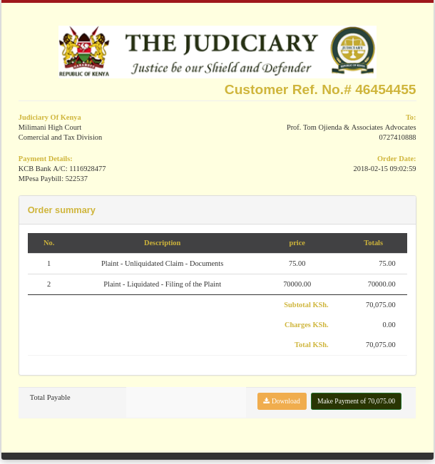

## Step 1. Verification

**1.1    With blank SOAP**

All request emanates from the KCB platform triggered by the payment request. The e-payment platform is expected to receive some specific parameters that triggers validation. This include **username**, **password**, **Customer reference Number.** Missing these parameters triggers a validation error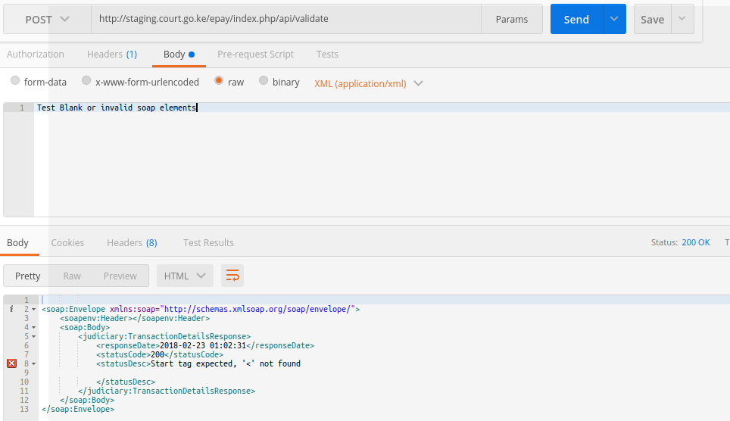

**1.2 Missing or invalid customer reference number**

From the KCB initial request, the efiling payment validation endpoint is expecting to receive a valid customer reference that must have been generated from the efiling platform. The amount to be paid must also match the amount requested and customer as well as the case number. This is to ensure that all payments are linked to a specific case number and customer.

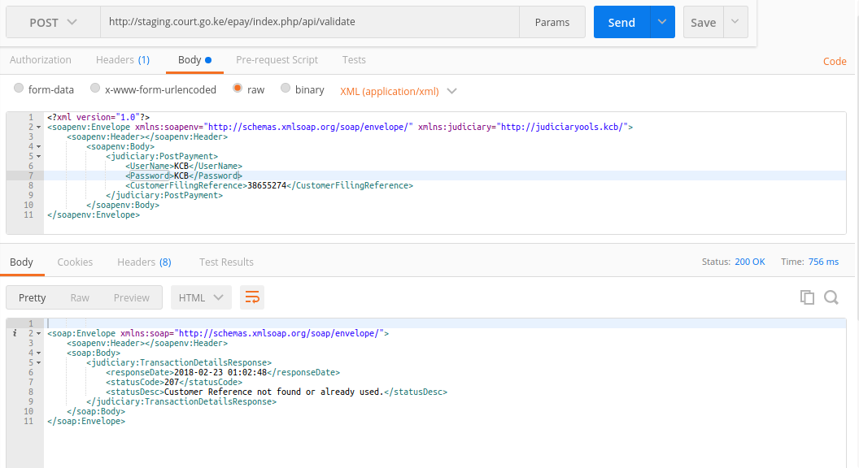

**1.3 Valid customer reference number**

Once a valid reference is presented to the e-filing validation endpoint, the validation responds with a status and the following critical parameters.

* Amount
* Bank Code for the station
* Account number for the station
* Name of the customer or lawfirm
* Case details

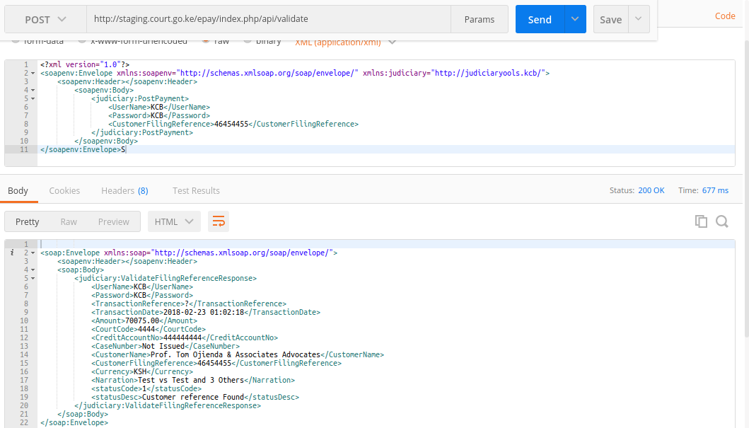

## Step 2

### 2.1 Payment Processing and Notifications

Once the validation is acknowledge by the efiling portal and payment processing is finalized by the KCB, The KCB send a payment notification to the efiling platform. The payment notification parameters include payment reference, customer details.

The payment parameter received from the KCB platform include is as follows:

### 2.2. Less amount other than what was validated.

We intend to force the customer to pay the exact amount mapped to the customer reference number. This is inline with the current mode of operation where the customer must pay the exact amount. There are proposal however to redevelop a wallet for customer who pay in bulk of small amount.

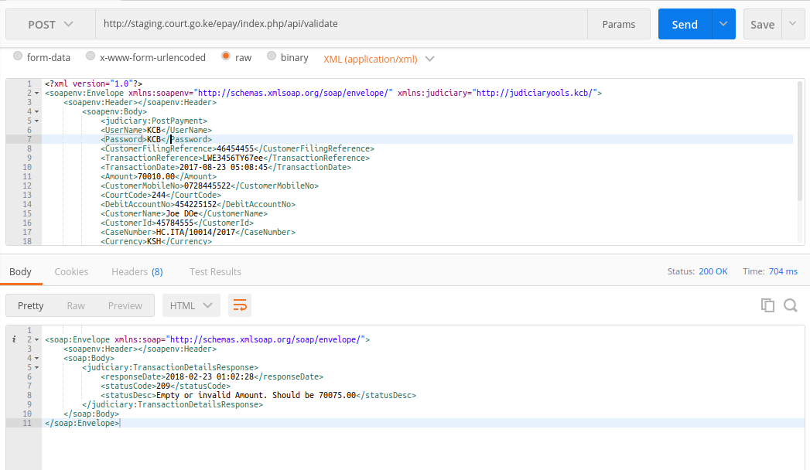

### 2.3 Valid amount

Once a valid amount is submitted and confirmed, we mark the customer reference as used and cannot be used again. We then proceed to generate a e-receipt

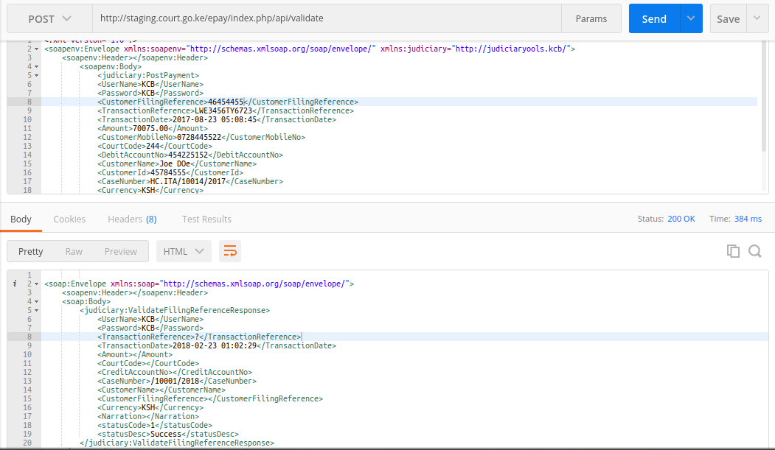

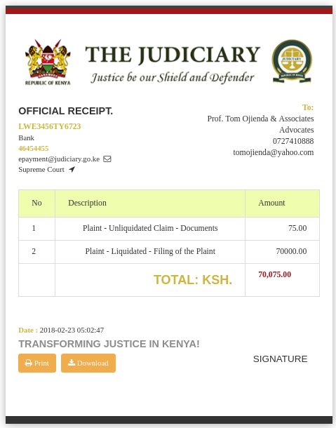

1. **Test customer references**

Below is a list of valid and invalid customer reference for testing purposes. This contain a **customer reference**, c**ustomer unique ID**, **case unique id**, **bank code**

|  |  |  |  |  |  |
| --- | --- | --- | --- | --- | --- |
| # | Customer | case | reference | Date generated | Bank code |
| 1 | 219 | 5926 | 23453450 | 2017-07-26 14:38:28 | 8888 |
| 2 | 219 | 5927 | 93355461 | 2017-07-26 14:38:28 | 4444 |
| 3 | 219 | 5928 | 33743662 | 2017-07-26 14:38:28 | 4444 |
| 4 | 221 | 5850 | 62453457 | 2017-07-27 04:07:26 | 4444 |
| 5 | 221 | 5850 | 23453458 | 2017-07-27 04:07:25 | 4444 |
| 6 | 220 | 5850 | 93355469 | 2017-07-27 04:07:20 | 8888 |
| 7 | 221 | 5851 | 33743660 | 2017-07-27 05:07:04 | 8888 |
| 8 | 221 | 5851 | 62453455 | 2017-07-27 05:07:52 | 8888 |
| 9 | 220 | 5903 | 23453451 | 2017-07-28 12:07:52 | 4444 |
| 10 | 3 | 3228 | 93355465 | 2017-10-12 03:10:48 | 4444 |
| 11 | 3 | 3670 | 33743663 | 2017-10-17 06:10:07 | 4444 |
| 12 | 3 | 3670 | 62453454 | 2017-10-17 07:10:14 | 4444 |
| 13 | 3 | 13697 | 56535673 | 2017-10-20 10:10:59 | 4444 |
| 14 | 704 | 13702 | 96375343 | 2017-11-04 09:11:32 | 4444 |
| 15 | 704 | 13703 | 84876339 | 2017-11-04 09:11:05 | 4444 |
| 16 | 704 | 13704 | 45969367 | 2017-11-04 09:11:46 | 4444 |
| 17 | 704 | 13705 | 76763959 | 2017-11-04 09:11:27 | 4444 |
| 18 | 662 | 13706 | 55269365 | 2017-11-04 09:11:06 | 4444 |
| 19 | 567 | 13710 | 72367673 | 2017-11-08 07:11:56 | 4444 |
| 20 | 522 | 13741 | 48668445 | 2017-11-15 11:11:09 | 4444 |
| 21 | 662 | 13793 | 42597692 | 2017-11-21 09:11:05 | 4444 |
| 22 | 662 | 74429 | 47768558 | 2018-01-24 02:01:28 | 4444 |
| 23 | 662 | 74430 | 84688565 | 2018-01-24 02:01:13 | 4444 |
| 24 | 662 | 74431 | 32743435 | 2018-01-24 02:01:29 | 4444 |
| 25 | 662 | 74432 | 37453366 | 2018-01-24 02:01:08 | 4444 |
| 26 | 662 | 74433 | 84774687 | 2018-01-24 02:01:04 | 4444 |
| 27 | 662 | 74434 | 77474537 | 2018-01-24 02:01:41 | 4444 |
| 28 | 662 | 74435 | 67635349 | 2018-01-24 03:01:18 | 4444 |
| 29 | 662 | 74436 | 24383955 | 2018-01-24 03:01:35 | 4444 |
| 30 | 662 | 74437 | 62548649 | 2018-01-24 03:01:48 | 4444 |
| 31 | 662 | 74438 | 34445453 | 2018-01-24 04:01:17 | 4444 |
| 32 | 662 | 74439 | 45552788 | 2018-01-24 04:01:53 | 4444 |
| 33 | 662 | 74440 | 28889368 | 2018-01-24 04:01:37 | 4444 |
| 34 | 662 | 74441 | 86944987 | 2018-01-24 04:01:01 | 4444 |
| 35 | 662 | 74442 | 77452972 | 2018-01-24 04:01:04 | 4444 |
| 36 | 662 | 74443 | 56626639 | 2018-01-24 04:01:28 | 4444 |
| 37 | 567 | 74482 | 77873565 | 2018-01-30 05:01:41 | 4444 |
| 38 | 567 | 74482 | 44833359 | 2018-01-30 05:01:37 | 4444 |
| 39 | 567 | 74482 | 28332826 | 2018-01-30 05:01:44 | 4444 |
| 40 | 567 | 74483 | 96858338 | 2018-01-30 01:01:20 | 4444 |
| 41 | 567 | 74480 | 83558875 | 2018-01-30 02:01:11 | 4444 |
| 42 | 567 | 74480 | 63365366 | 2018-01-30 07:01:29 | 4444 |
| 43 | 567 | 74480 | 33566454 | 2018-01-30 07:01:22 | 4444 |
| 44 | 567 | 74480 | 75778763 | 2018-01-30 08:01:59 | 4444 |
| 45 | 567 | 74480 | 27662663 | 2018-01-30 08:01:13 | 4444 |
| 46 | 567 | 74480 | 68358372 | 2018-01-30 08:01:50 | 4444 |
| 47 | 567 | 74480 | 79543887 | 2018-01-30 09:01:53 | 4444 |
| 48 | 567 | 74490 | 35466624 | 2018-02-02 04:02:43 | 4444 |
| 49 | 662 | 74433 | 37849835 | 2018-02-08 02:02:39 | 4444 |
| 50 | 662 | 74434 | 54596246 | 2018-02-14 05:02:29 | 4444 |
| 51 | 662 | 74436 | 46454455 | 2018-02-15 09:02:59 | 4444 |
| 52 | 536 | 74504 | 66535768 | 2018-02-15 10:02:42 | 4444 |
| 53 | 528 | 74505 | 88338534 | 2018-02-15 12:02:17 | 4444 |
| 54 | 528 | 74507 | 56572344 | 2018-02-21 11:02:54 | 4444 |
| 55 | 528 | 74508 | 45586647 | 2018-02-21 12:02:03 | 4444 |
| 56 | 546 | 74509 | 76865567 | 2018-02-22 11:02:20 | 4444 |
| 57 | 547 | 74514 | 52743348 | 2018-02-22 07:02:56 | 4444 |